First Name Last Name
TRANSFORMATIONAL LEADER & BOARD MEMBER

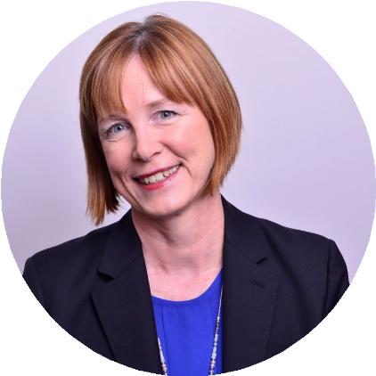

CONTACT:

Phone:
(000) 000-0000

Email:
e-mailaddress@gmail.com
LinkedIn:
linkedin.com/in/name

BOARD LEADERSHIP

Board of Directors
2014 – 2020
Foundation Name

Strategic Planning Consultant
2011 – 2016
Museum Name

Board of Directors
2006 – 2011
Organization Name

LANGUAGES
English (Native)
French (Fluent Verbal and Written)

Dual US & UK Citizenship

EDUCATION & TRAINING
Bachelor of Arts
Management Studies & French
University Name

Organizational Development Certification
Organization Name

IDEO Design Thinking Six Sigma Black Belt
Globally experienced executive and change catalyst recognized for leading organization-wide transformations that drive growth, increase profitability, and expand executive team diversity.
Equipped with a holistic perspective, drawing on leadership experience spanning sales, operations, manufacturing, supply chain, and HR.
Trusted board advisor providing strategic insights.

SELECT LEADERSHIP CONTRIBUTIONS
Held executive HR and business strategy roles for 4 multinational, multibillion- dollar enterprises (CPG, life sciences / biotech, and technology).
Globally experienced after living and working in UK, France, China, and North America with worldwide team leadership across 60 countries on 6 continents. Built new capabilities and delivered hundreds of millions in OPEX savings through business process redesign, global restructures, and organizational development initiatives.

CAREER HIGHLIGHTS
COMPANY NAME 2014 – 2020
Chief Human Resources Officer
COMPANY NAME 2009 – 2014
Vice President, Human Resources, Global Operations Vice President, Human Resources, Greater China Vice President, Head of Talent
COMPANY NAME 2003 – 2009
Chief Human Resources Officer
COMPANY NAME 1999 – 2003
Senior HR Manager / OD Manager ➝ HR Director, Global Operations ➝
HR Director, Sales and Marketing
COMPANY NAME 1988 – 1999
Sales Territory Manager ➝ European Purchasing Manager ➝ Operations Shift Manager ➝ Training & Communications Manager ➝ Senior HR Manager
ADDITIONAL WORK
COMPANY NAME 2021 – Present
Founder & CEO – Organizational Development Consulting HR & capability planning strategies to help purpose-driven leaders scale their organizations globally.
COMPANY CORPORATE FOUNDATION 2020 – Present
Executive Director

Sample Created by Debra Boggs at D&S Executive Career Management www.dscareermanagement.com

